Details of Professional Indemnity Insurance
Details of Relevant Qualifications & Experience In Real Estate Work
Code of Ethics

As required under the Real Estate Agents (Exemptions) Regulations 2017 and NZIF Rules

I (name) Sonja Lukaszewicz_____________________________________ (please print)

hereby submit the following:

1 PI INSURANCE
I have Professional Indemnity Insurance Yes/No
If yes, is the cover provided:
- by me personally Yes/No
- by my employer/company Yes/No

2 REAL ESTATE QUALIFICATIONS & EXPERIENCE
I have the following qualifications and/or experience in real estate work (enter nil if none):
Nil

3 CODE OF ETHICS
I have read the NZIF’s Code of Ethics and, in completing this form, affirm that I understand and agree to abide by them. Please tick

The Code of Ethics is on the NZIF website under About Us/Governing Documents.

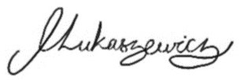
Signed: ______________________________

Dated: 31/01/2024_____________________

Form 9

