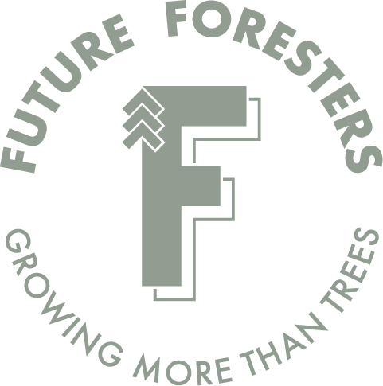
FRESTRA Young Forester
of the Year Award
2023

Official 2023 Award Nomination Form

This award recognises an individual future forester who has displayed commitment and passion for the forestry industry or their forestry profession. This will be awarded to a young Forester who aligns themselves with the original values of the historic FRESTRA Club and the current values of the NZ Future Foresters and demonstrates commitment to social connection, developing the forestry community, and taking forestry into the 21st century and beyond.
The successful recipient will receive their name engraved on the FRESTRA Young Forester of the Year Award, a $1,000 cash reward, and $1,000 to go towards a field trip anywhere in New Zealand hosted by Future Foresters.

Nominee Name:
Contact Person (Nominator):
Email:
Contact number:
Award nominations must be received before: Friday 5pm 16th June 2023.
The award will be announced at the Awards Dinner of the NZ Institute of Forestry AGM on Saturday 8th July 2023 in Wellington. A recipient can only successfully receive the award once and must be a citizen or resident of New Zealand and aged 31 years or younger at the time of nomination.
Please email nominations to: admin@nzif.org.nz

Criteria for Assessment: Please explain how this young forester demonstrates their commitment to the New Zealand forest industry, their profession, and the values of NZ Future Foresters and the historic FRESTRA club, and why they deserve the award. Nominations are to be 1 page or less (size 11 Calibri font).
The following criteria will be assessed to decide on the successful nominee:
- Involvement in the NZ Future Foresters (or are able to demonstrate that they will be).
- Demonstrates a sense of forestry community.
- Promotes forestry as a diverse and rewarding career.
- Champions young foresters to have their voice heard.
- Works towards acknowledging and recording forestry history.
- Encourages foresters of all ages to connect.
- Demonstrates leadership within the industry or their profession.
- Be recognised by their peers, company, clients and wider industry (we will accept a maximum of 2 letters of endorsement from people not associated with the nominator).

The award will be decided by the Award Committee selected from individuals previously involved in Future Foresters, FRESTRA, and the NZIF.

