International Virtual Study Tour 2021
Future Proofing our Forests

Join us and the Institute of Foresters of Australia and the New Zealand Institute of Forestry for our International Virtual Study Tour 2021 as we welcome forestry professionals from across the globe who will provide fascinating insights into international forest operations and management.

Featuring speakers from the UK, New Zealand and Australia, this event will showcase recent industry developments and allow professional foresters to share ideas and working practices for the benefit of all our trees and woodlands. We’ll experience virtual tours of forests; learn about future-proofing our woodlands; discover technical developments aimed at improving health and safety in the sector, and analyse conservation and protection issues in forestry. This is a truly international event not to be missed!

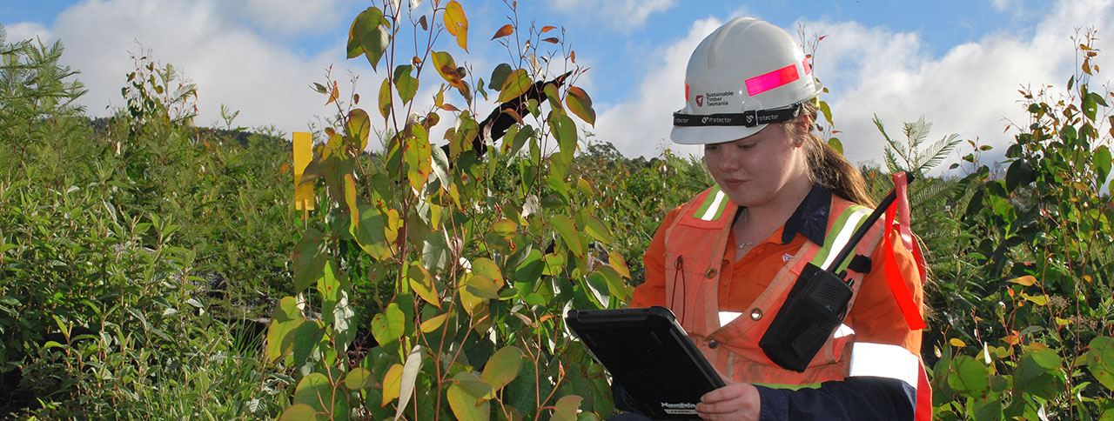

Presentations

Future Proofing Our Forests
Join the Chatsworth forestry team for a virtual tour of the forests and woodlands that make up the stunning Chatsworth Estate. Learn about the current challenges facing UK woodlands to provide a variety of resources and services and what is being done at Chatsworth to not only meet these needs now, but ensure they will continue to be met long into the future. It is critical that forests are managed in a way which will enable them to be resilient to the inevitable changes caused by climate change, the increased pressures due to population growth and those suddenly brought on by the global pandemic. This tour will showcase the forest management, continuous cover operations and woodland creation being carried out on the Chatsworth Estate in a bid to future-proof its forests and ensure they remain a valuable part of the Estate.

Forestry the New Zealand Way
In this session, a host of forestry professionals from NZ will present as we visit the Southern hemisphere’s largest man-made forest; hear from one of New Zealand’s Future Foresters; listen to forest scientists discuss the future of forestry, and discover how NZ is working to remove the human element from the dangerous work of harvesting on steep hill country. New Zealand forestry is rapidly adapting and changing to new demands while continuing to contribute 2% to GDP and grow export revenues.

Managing Tasmania’s Forests for Multiple Values
Join representatives from Sustainable Timber Tasmania as they outline how they manage public production forests for multiple outcomes, with a focus on active and adaptive land management and investing in smart forests for the future. As an active and adaptive forest manager, Sustainable Timber Tasmania aims to maintain and enhance the conservation and protection of forest values – specifically related to management, accessibility, and availability for multiple uses.

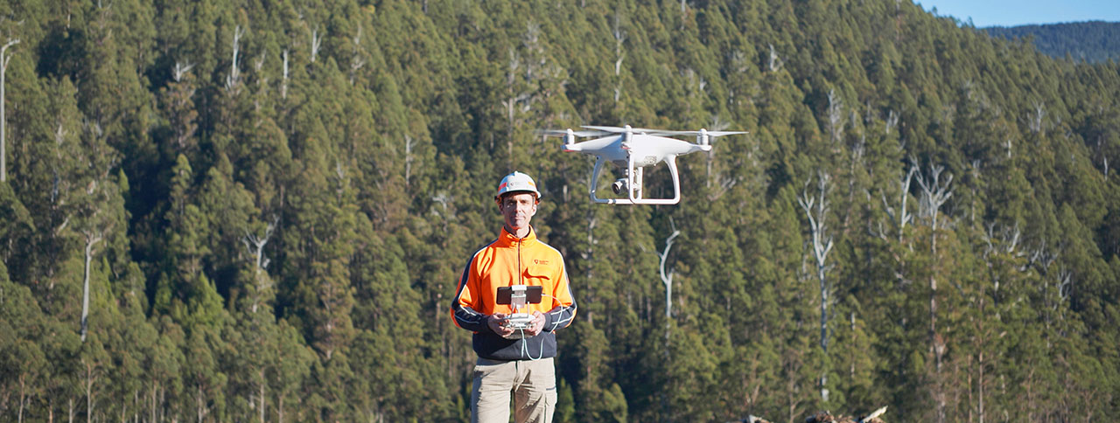

Chair

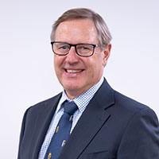
Rob de Fégely – Director, Margules Groome Consulting Pty Ltd
Rob de Fégely is chair of the board of Sustainable Timber Tasmania (formerly Forestry Tasmania) and a non-executive director and national vice president of the Institute of Foresters of Australia. He has also held advisory roles with Greening Australia and the NSW National Parks and Wildlife Service. He has worked in the Australian forest industry for 38 years and travelled extensively in the Asia Pacific region. He is a Registered Professional Forester with a Bachelor of Science (Forestry) degree from the Australian National University and a Master of Science (Forest Business Management) from Aberdeen University in the United Kingdom. In his spare time, he and his wife Sarah run a small farm and forestry enterprise on the far south coast of New South Wales.

Speakers

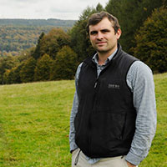
John Everitt – Forestry Manager, Chatsworth Estate
John is a 5th generation forester with a strong family background in the Forestry Commission. His first job was lifting seedlings aged 11 at Wykeham Nursery under his father. John went on to study for a BSc (Hons) in Forestry and Forest Products at Bangor University, undertaking his mid-year placement in the Forest of Dean. Upon graduation, John worked in the Scottish Boarders and South Scotland for the Forestry Commission under multiple roles including Forest Management Work Supervisor, Wind Farm Liaison Officer, Programme Manager and Planning Forester. In 2016 John became the Forestry Manager for the Chatsworth and Bolton Abbey Estate managing 2400ha of mixed woodlands across Yorkshire and Derbyshire as well as being responsible for the trees over 75,000 acres of estate land.

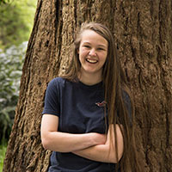
Jemima Letts – Assistant Forester, Chatsworth Estate
Jemima graduated in 2019 with a BSc (Hons) Forestry degree from Bangor University. Jemima worked as an Outdoor Activity Instructor over her summer semesters, discovering her passion for sharing her love and knowledge of trees and natural history. During her studies, she set up a successful social enterprise, Tree Sparks, for which she has received a raft of accolades including being awarded the Changing Attitudes Award at Confor’s Award Dinner in 2020. This led Jemima to working freelance as a public speaker during her final years of study speaking at various events including the ICF’s 2019 National Conference. Jemima secured a 12-month placement on the Chatsworth Estate as Trainee Forester upon graduation and is now working full time on the Estate as Assistant Forester.

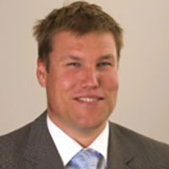
James Treadwell – President, New Zealand Institute of Forestry
James is the President of the New Zealand Institute of Forestry for 4 years, VP for 2 and CEO of IFS Growth Ltd. James has been instrumental in helping organisations build teams, undertake strategic reviews and plan and implement growth. He always looks for ways to improve and thrive in changing environments, confidently leading a team to a strong result. His encyclopaedic forestry knowledge and experience was honed in forests throughout Australasia over the past two decades and he is passionate about the industry. When James does get free time, this is spent falling off bikes and other moving objects. He has probably broken most bones in his body. He has a good sense of humour but drinks way too many short blacks and does not like to choose his own meal when dining out

Dale Ewers – Founder, DC Equipment
Dale is incredibly passionate about the logging industry and his mission in life is to make it safer and more productive for everyone involved. Having been a logger since the age of 14, Dale currently manages 16 logging crews throughout New Zealand. In 2012, Dale and his logging managers made the decision to fully mechanise. Unable to find existing equipment to fulfill their needs they developed their own motorized Grapple Carriage, Grapple Camera System and Winch Assist Machine. Under the Falcon Forestry Equipment brand, these products are now sold in New Zealand, Australia, Chile, Canada and the U.S. Dale and the team at DC are also currently developing the world’s first remotely operated Felling Grapple Carriage which will allow the Yarder Operator to fell and extract trees all from inside the safety of the Yarder cab.

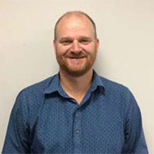
Colin Maunder – Sustainability Manager, Timberlands
Colin has over 25 years’ experience in most aspects of forest management, his specialises in forest risk management including environmental safety, fire and security management of plantations. Colin graduated from University of Canterbury with a BForSc and an MSc in Environmental Sciences. He is a member of the NZ Institute of Forestry and the Environmental Institute of Australia and New Zealand.

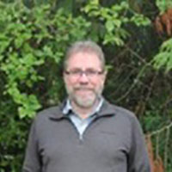
Tim Payn – Professor of Sustainable Forestry, Toi Omohai Institute of Technology
Tim questions “How do we communicate information and facts about New Zealand’s forests?” He is interested in why myths about forests grow and are perpetuated, what sorts of information people are interested in, the importance of social and other media types, and what makes a good communicator. We’ve explored several ways to communicate – he will use his background in environmental forestry to develop environmental fact sheets: key facts about topical issues e.g. biodiversity in planted forests, or debris flows. Working with international and national groups he has developed indicators of sustainable forestry that allow people to get a clear picture of all aspects of a forest – social, environmental, economic, and cultural, and developed a web portal for information on New Zealand’s planted forests.

Adrian Loo – Future Forester NZ
Adrian is a past graduate of the University of Canterbury having completed a Bachelor of Forestry Science with First Class Honours a Certificate in Commerce. He is a founding member of the Future Foresters and is actively involved in a leadership role within this initiative. Adrian currently works within the Canterbury Region in an ETS/Project Manager role for Forest Management Limited. In addition to his full-time job Adrian is studying a Master of Forestry Science degree at the University of Canterbury. Adrian is a graduate NZIF member and has been co-opted onto the council as a Future Foresters representative.

