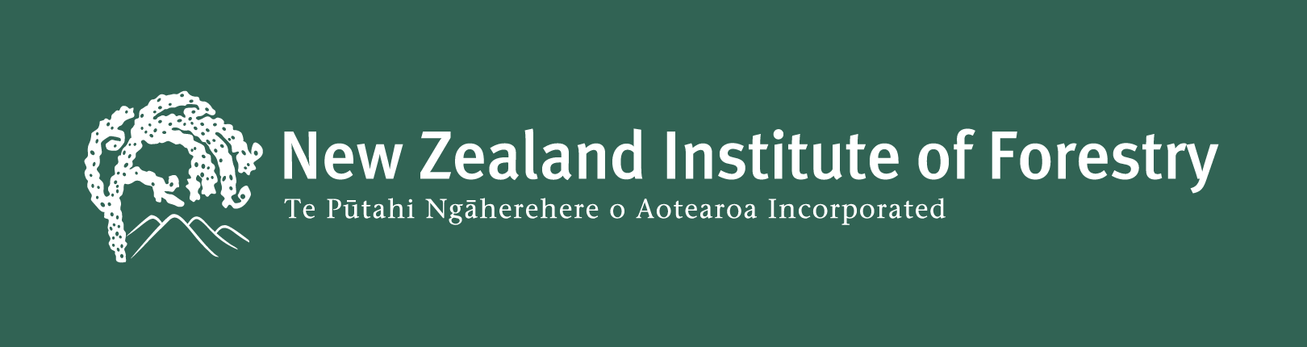

Declaration of Eligibility For Application For NZIF Registered Member

Declaration made in the manner prescribed by Section 9 of the Oaths and Declarations Act 1957 to support determination of eligibility to be a Registered Member of the New Zealand Institute of Forestry – Te Pūtahi Ngāherehere O Aotearoa Incorporated.

I, [insert full name], of [insert place of abode and occupation] solemnly and sincerely declare that:

- I have not been convicted, whether in New Zealand or another country, of a crime involving dishonesty (or of a crime that, if committed in New Zealand, would be a crime involving dishonesty) within the 10 years preceding the date of this declaration;
- I have not been convicted of an offence under the Fair Trading Act 1986, within the five years preceding the date of this declaration;
- I have not been licensed under the Real Estate Agents Act 2008 and had my licence cancelled within the five years preceding the date of this declaration;
- I am not prohibited from being a director or promoter of, or being concerned or taking part in the management of, an incorporated body;
- I am not an undischarged bankrupt or subject to subpart 4 of Part 5 of the Insolvency Act 2006.

And I make this solemn declaration conscientiously believing the same to be true and by virtue of the Oaths and Declarations Act 1957.

[Signature]

Declared at [enter place, date]

Name and Signature of Witness
(Justice of the Peace or other person authorised to take a statutory declaration)
Form 10

